Face Recognition Unlocking System

INTRO:

The face recognition system is part of facial image processing applications, and it is one of the challenging topics in IT research. Biometric information on humans is used instead of a fingerprint, iris, signature, etc. because these types of biometrics are not suitable for non-collaborative people. Face recognition systems are usually used and preferred for security cameras in metropolitan life. These systems can be used for crime prevention, video surveillance, person verification, and similar security activities.

Face detection is the first step of the face recognition system. The output of the detection is the location of a face region with facial features (i.e., eyes, mouth, eyebrows, nose, etc). Detection methods are classified into two groups knowledge-based methods and image-based methods.

AIM:

To improve the security system with AI (Artificial Intelligence) we aimed to build a FACE LOCKING SYSTEM, where a door will be locked and unlocked through the face. To achieve the need we have worked on Python 3, to build a source code and perform operations after recognizing.

OBJECTIVE:

Face detection and face recognition describe an efficient algorithm using an open-source image processing framework known as Opencv and Dlib. It is used for image processing applications to load the images into the system and process the images. Our approach has four modules – Face Detection, Face Preprocessing, Face Training, and Face Recognition.

The system is initially trained with the faces which are collectively known as a database. The system uses a user-friendly interface to maximize the user experience during both training and testing which is collecting single images and detecting them.

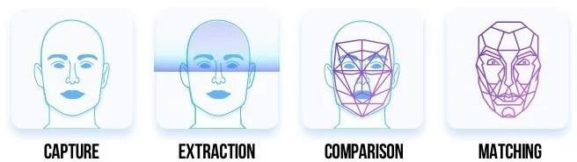

PROPOSED WORK:

The proposed work is as follows:

- Interfacing a high-definition image of individuals for training.
- Create a database of the authorized person.

- Capture the current face, save it, and compare it with the database image.

- Display the authorized person details like ID Picture, Employer ID, Department, and Designation, and IN time.

WORKFLOW:

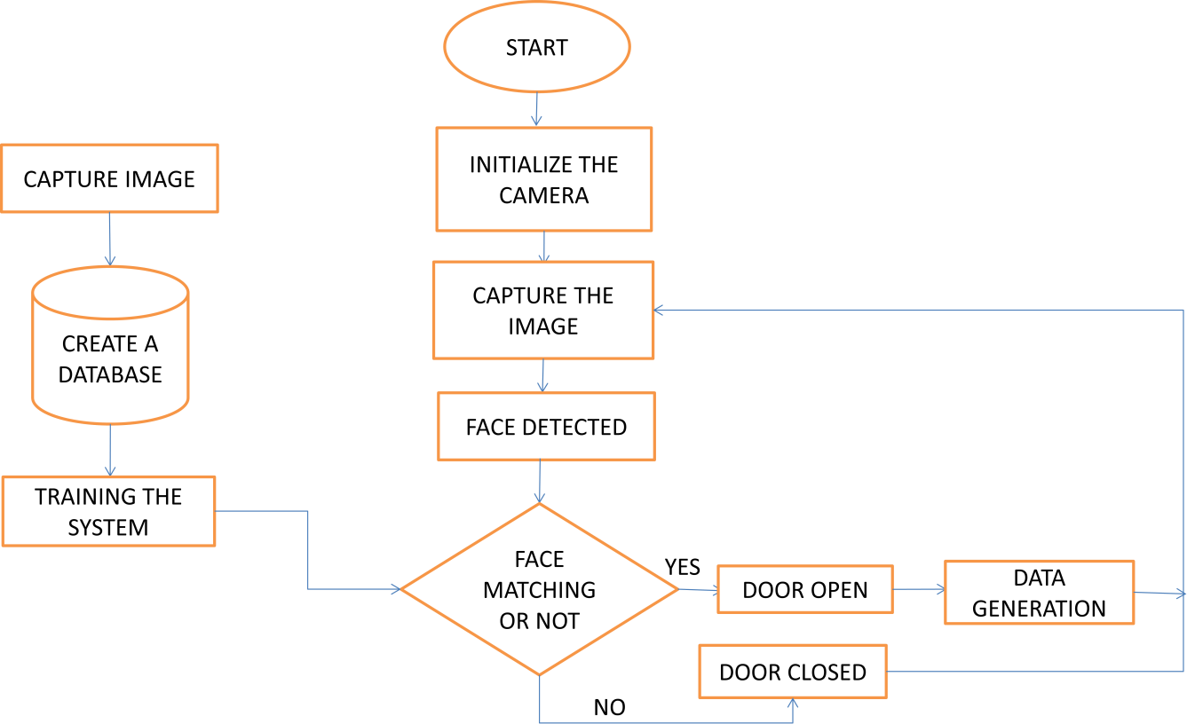
TRAINING OF IMAGE:

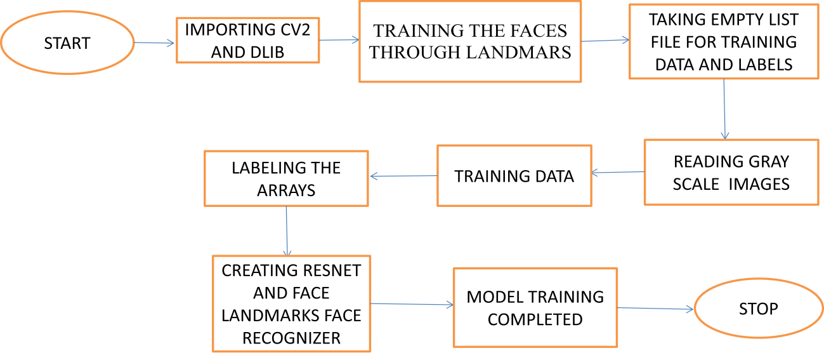

RECOGNITION
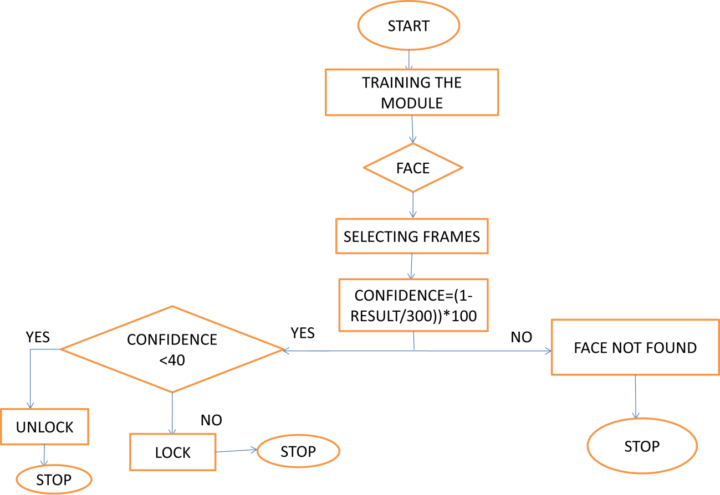
ARCHITECTURE:
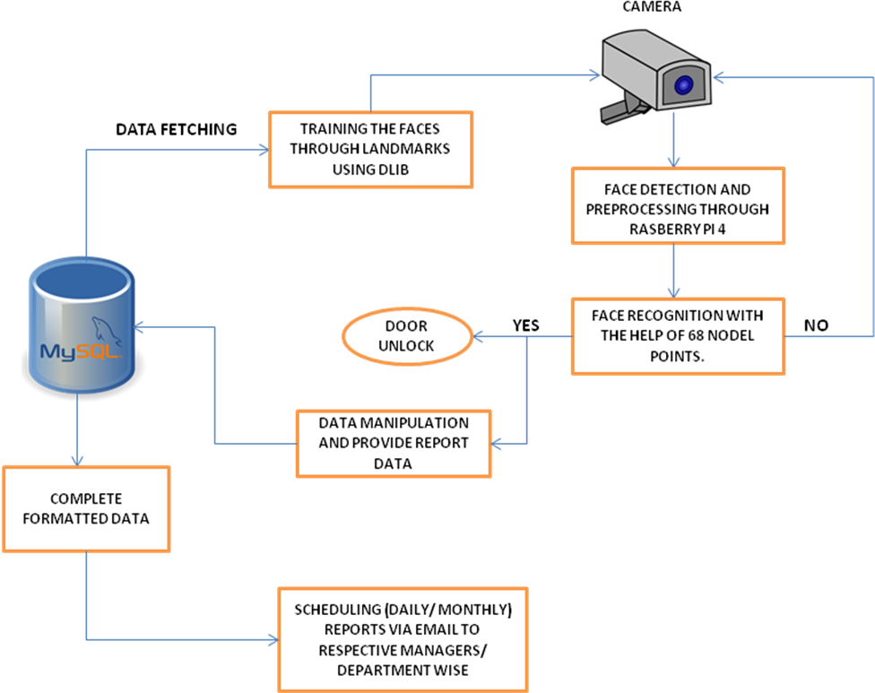

Working procedure: 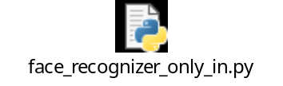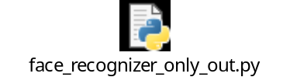

Initially, we need to train a system to recognize the faces, and it should be trained with specific faces to unlock the door. To build this we have followed a few steps, as follows.

Step 1: Need to train a model to identify the faces.

To perform this, we have taken a sample single image of every person whose face has to be recognized, we store each image in a separate folder to make the system understand that person with the name as a label.

Step 2: Need to make a list with labels of images.

After taking the sample images, we will label the images with the person's name, and we create a dictionary with trained faces label with a unique ID that holds a username.

Step 3: Need to create a recognizer for facial features.

After training the faces, we must build a recognizer with the dlib existing modules (resnet and landmarks). With the help of these modules, it will read an image of individuals and store their values.

Step 4: After finishing the training, we will directly apply it to the live video and check how accurate it is in detecting and recognizing a face.

Step 5: Once the person has been recognized with accuracy. His/her data will be displayed for that identified person.

Step 6: Allowing MySQL server to be queried from a remote host and by creating a user on the MySQL server that allows a user from the Pi to connect, we retrieve data.

Requirements: Hardware Requirement:
  - System

  - Camera

  - Raspberry Pi 4

  - Display/Relay

Software Requirement:

  - Python

  - Mysql

Dlib Model:

Detecting facial landmarks is therefore a two-step process:

Step 1: Localize the face in the image.

Step 2: Detect the key facial structures on the face ROI.

With the help of the Dlib library, we are localizing 68 landmark points within a face image. Feature points are such as:
- Points 0 to 16 is the Jawline
- Points 17 to 21 is the Right Eyebrow
- Points 22 to 26 is the Left Eyebrow
- Points 27 to 35 is the Nose
- Points 36 to 41 is the Right Eye
- Points 42 to 47 is the Left Eye
- Points 48 to 60 is Outline of the Mouth
- Points 61 to 67 is the Inner line of the Mouth.

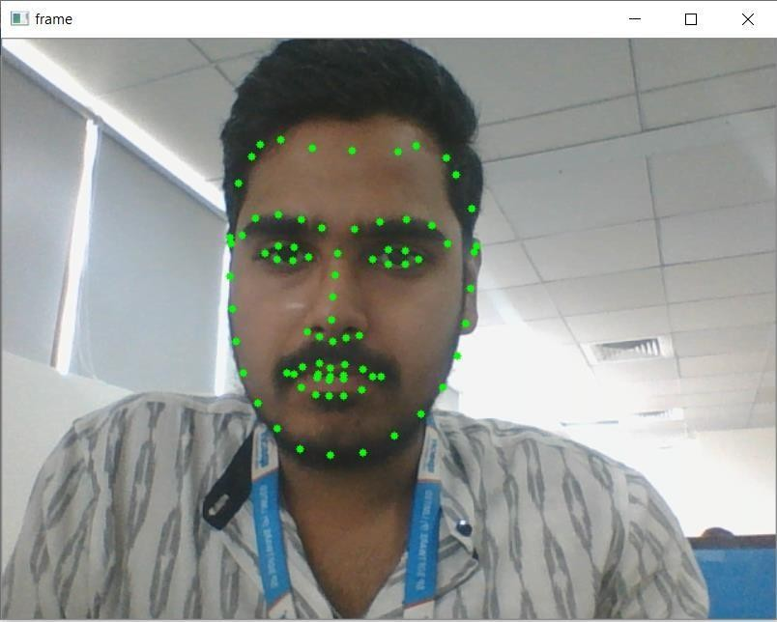

Mounting Angle of Camera:

The face detection algorithm can tolerate up to 45-degree angle error. Certainly, clear face images will reduce omissions.

Camera Installation:
- Cameras should be installed in the Angular direction.
- Camera installation height depends on resolution, typically 1.7 meters.
- Registration: pixel distance between eyes - min 100 pixels
- Recognition: pixel distance between eyes - min 100 pixels
- Detect faces typically up to a distance of 3 meters from the camera. The actual distance depends on the camera installation height and the associated angle of incidence.
- Constant illumination throughout the day (> 200 lux).
- Detection: pixel distance between eyes – min 60 pixels

Horizontal Angle:

The horizontal angle means the angle between the camera and the horizontal direction of the positive direction face. The limit should be below 45 degrees. It is recommended not to exceed 30 degrees.
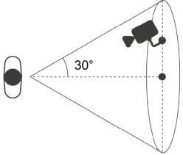

Vertical angle:

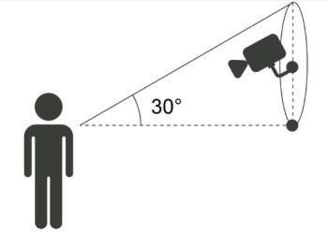
Vertical angle means the angle between the camera and the vertical direction of the positive direction face. The limit should be below 45 degrees. It is recommended not to exceed 30 degrees.

Challenges:

Here, these are the challenges that limit the potential of our Facial Recognition System to go that extra mile as these challenges have constantly played with the quality of delivery.
- Illumination:
A slight change in lighting conditions has always been known to have a major impact on our results, as such detection and recognition have been difficult.
- Pose variation:
Our system is highly sensitive to pose variations. It only detects when it finds a complete face to recognize, side angle face recognition is a bit hard to get close to, due to landmarks.
- Occlusion:
Occlusion of the face such as cap, mask, and shades also evaluation of a face recognition system. Our system does not detect or recognize when a person comes up with a handkerchief tied to his face or for some reason having their face covered with their hands and a person with mouth open.
For a person with a cap, up to 45 degrees of camera resolution the face reorganization doesn’t work.
- Camera:
Based on camera resolution the distance of recognition distance has been varying.

Testing Methods:

We tested our system based on different scenarios where detection and recognition are done successfully.
- Tested based on aging variations through face application.
- Tracking the moving face and recognition is done within a fraction of a second.
- Even if the eyes are closed, the system has been detecting faces.
- Though the person with or without beard and mustache appearance faces are recognized.
- Depending on camera specification, the distance of detection and recognition varies.
- Through streaming sources, faces are recognized.
- Within a frame, multiple faces are being recognized.
- Photo pictures and phone pictures with faces are detected.
- The camera angle of detection, from the top is up to 45 degrees, and from the bottom angle with 30 degrees.

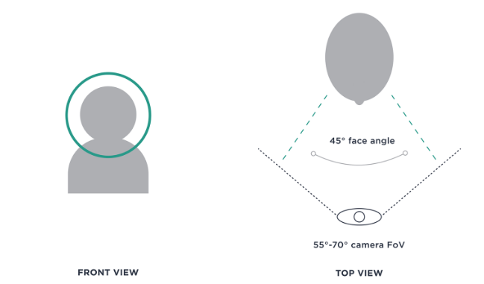

INSTALLING PROCESS:

DOWNLOADING THE RASPBIAN OS:

Here’s how to get the Raspbian os onto your SD card:

Head on over to the official BusterOS download page and start your download.

“Raspbian Buster with Desktop and recommended software”.

Download Balena Etcher — software for flashing memory cards. It works on every major OS.

Use Etcher to flash BusterOS to your memory card.

After downloading the Raspbian Buster .img file you can flash it to your micro-SD card using Etcher

After a few minutes the flashing process should be complete — slot the micro-SD card into your Raspberry Pi 4 and then boot.

At this point, you have an SD card loaded with the Raspbian os.

PLUGGING EVERYTHING IN:

Plug in a mouse and keyboard to the USB ports.

Plug in a monitor using an HDMI cable.

Plug in an Ethernet cable to the network port and make sure the other end is plugged into your router.

Finally, plug in the MicroUSB power cord.

FIRST BOOT AND USER ACCOUNT CONFIGURATION:

The first time the Raspbian os boots, you must go through the standard Linux new user process. You select the type of keyboard you are using, create a user account, and pick a password. When you are done, you’ll see a blank Linux desktop.

At this point, Python 3.7 and OpenCV are already installed. You can open up a terminal window and start running Python programs right now just like on any other computer. But there are a few more libraries that we need to install before we can run our Face recognition system.

EXPAND FILESYSTEM AND RECLAIM SPACE:

You have an SSH or VNC connection established with your Pi. Alternatively, you could use a

Keyboard + mouse + screen.

Go ahead and insert your microSD into your Raspberry Pi and boot it up.

Once booted, configure your Wi-Fi/Ethernet settings to connect to the internet (you’ll need an internet connection to download and install the required packages for OpenCV).

From there you can use SSH or go ahead and open a terminal.

INSTALLING REQUIRED PYTHON LIBRARIES:

To build our face recognition system, we need to install several Python libraries.

From the Raspbian desktop, open up a Terminal window and run the supportive commands.

SQL SERVER INSTALLATION:

Click on the 'Setup' application and Click on Installation

Click on “Add Current User” and click the Next button.

After installation, Click Start type “ssms” and press enter.

The first time you run SSMS, the Connect to Server window opens. If it doesn't open, you can open it manually by selecting Object Explorer > Connect > Database Engine.

Click on “Connect” to connect to the server.

Into the query window, paste the following T-SQL code.

Create database test_dataview and click on execute or press F5.

In the database drop-down list, select the database that you want to use, as shown here. Or “USE” is the command to switch to the required database.

REPORTING SYSTEM: 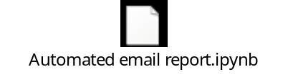

Once the face is recognized, the employee data will be stored in MySQL where data gets fetched with required manipulations and saved the report in the CSV format.

Generated CSV file of employee data will be emailed to respective reporting managers.

OUTPUT:

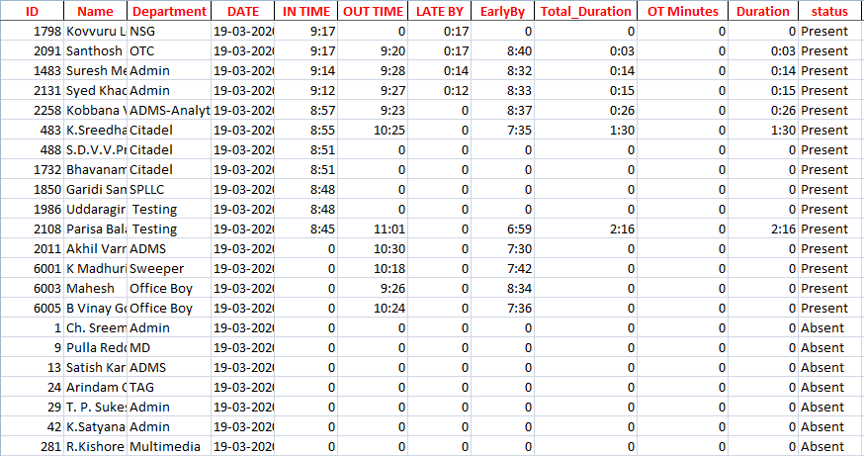

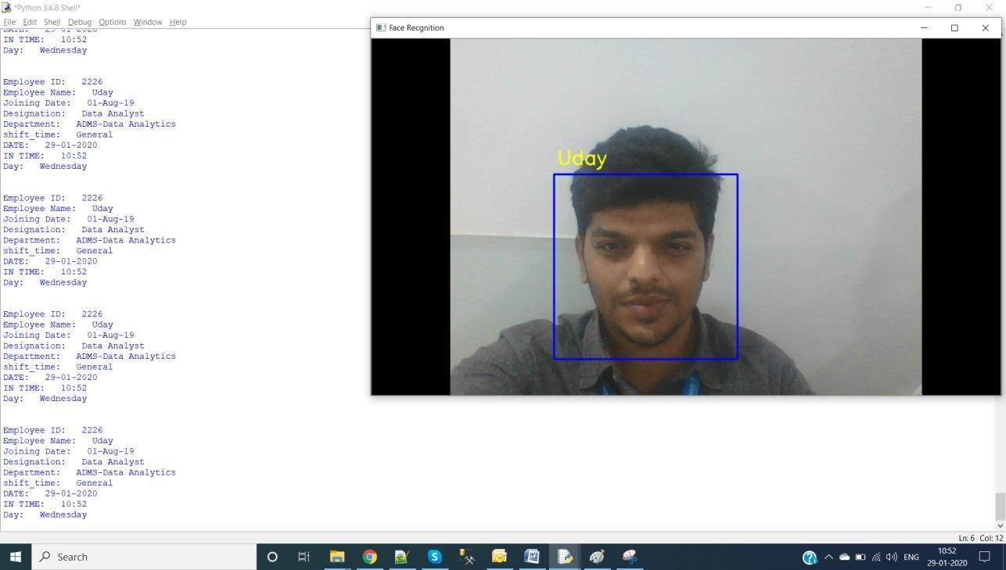

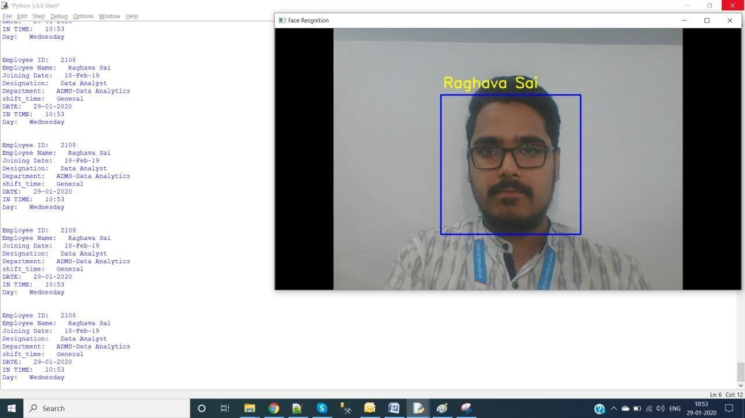
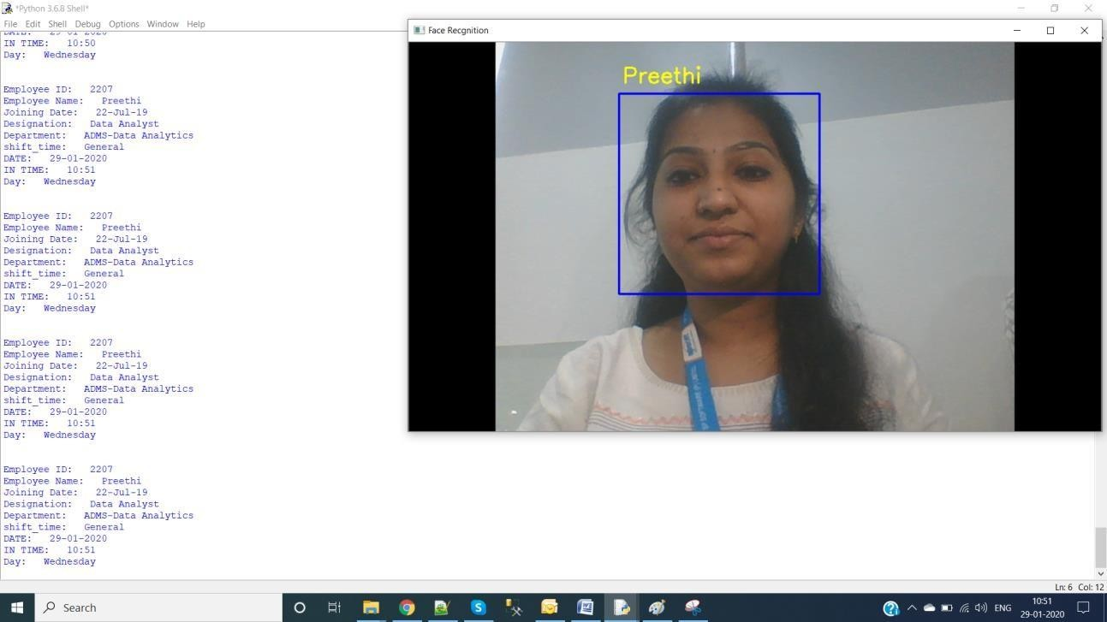

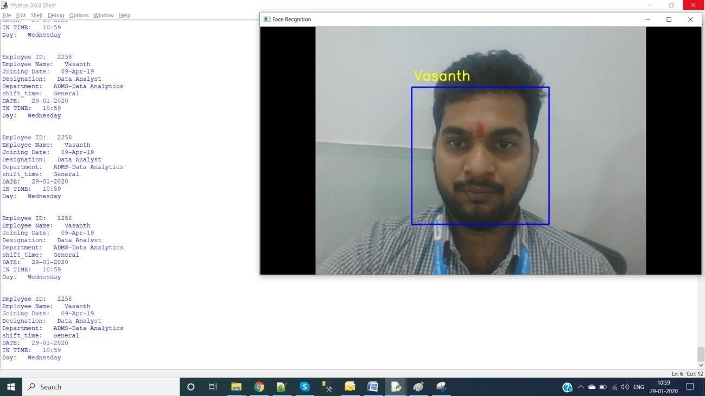
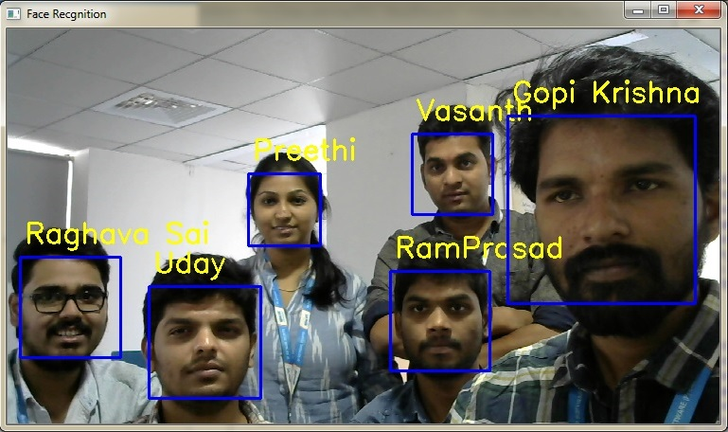

CONCLUSION:

In this proposed door access system, by using face recognition the images are stored in a database. This system is used for door lock access for an organization. Here we have designed a highly secured door-locking system by using OpenCV and Dlib libraries.

FUTURE SCOPE:

The current project can be modified by an Infrared camera interfacing it can be used in a Smart Surveillance Monitoring security system which any type of public security uses Living body detection or spying. Also, some profound applications can be implemented using interfacing of sensor applications of smartcard swapping, finger detection, alcohol detection, agriculture humidity sensing, Temperature sensing using web servers, and many more.

The general experimental evaluation of the face expressional system guarantees better face recognition rates. Having examined techniques to cope with expression variation, in the future, it may be investigated in more depth about the face classification problem and optimal fusion of color and depth information. Further study can be laid down in the direction of allele of gene matching to the geometric factors of the facial expressions. The genetic property evolution framework for facial expression systems can be studied to suit the requirements of different security models such as criminal detection, governmental confidential security breaches, etc.

